RANDOM VARIABLES AND PROBABILITY
DISTRIBUTION ANALYSIS USING REAL-WORLD DATA
A Statistical Analysis of SPDR S&P 500 ETF Trust (SPY) Daily Market Data
Prepared by: Ayush Anand
Christ University, Delhi NCR
B.Sc. Data Science & Artificial Intelligence

Submitted to: Dr. Swati Aggarwal

1. Introduction
Probability distributions provide a mathematical way to describe how the values of a random variable are distributed. In real-world datasets, variables may be discrete, taking specific countable values, or continuous, taking values over a range.
This study applies the concepts of random variables, probability mass functions (PMFs), probability density functions (PDFs), and cumulative distribution functions (CDFs) to real-world financial market data. The SPDR S&P 500 ETF Trust (SPY) was selected as the dataset because its daily market data provides several measurable variables that can be analyzed statistically.
The analysis focuses on five variables: Daily Return, 21-Day Rolling Volatility, Daily Spread, Trading Volume, and PositiveDay. These variables were classified as discrete or continuous and their distributions were examined using empirical probability calculations, graphical methods, and statistical measures.
The study also performs exploratory data analysis and fits a Normal distribution to selected continuous variables using Maximum Likelihood Estimation. The results are used to identify important characteristics of the data and interpret the probability distributions.

2. Dataset Description and Data Collection
The dataset used in this study consists of historical daily trading data for SPY. The data was obtained programmatically from Yahoo Finance using the R programming language and the quantmod package.
The observation period begins on 1 January 2016 and extends to the date on which the data was collected. The original market data contains daily Open, High, Low, Close, Volume, and Adjusted Close prices.
Additional variables were calculated from the original market data using R. The main derived variables used for probability analysis are:
- Return – logarithmic daily return calculated using the Adjusted Close price.
- Volatility21 – 21-day rolling standard deviation of daily returns.
- Spread – difference between the daily High and Low prices.
- Volume – number of shares traded during the day.
- PositiveDay – indicator showing whether the daily return was positive.
After removing observations containing missing values resulting from the calculations, the final dataset contained 2,623 observations and 15 variables. The dataset was exported as SPY_Probability_Assignment.csv for further analysis.

3. Variables Selected and Classification
Five variables were selected for the probability distribution analysis.
Variable | Type | Classification | Justification
Return | Continuous | Continuous R.V. | Logarithmic change in adjusted price; can take decimal values over a range.
Volatility21 | Continuous | Continuous R.V. | Standard deviation of returns; can take decimal values.
Spread | Continuous | Continuous R.V. | High − Low price difference; can take decimal values.
Volume | Discrete | Discrete R.V. | Number of shares traded; takes countable integer values.
PositiveDay | Discrete | Discrete R.V. | Only two possible outcomes: 0 (non-positive) or 1 (positive).

3.1 Continuous Random Variables
Return, Volatility21, and Spread are treated as continuous random variables because their observed values are numerical measurements that can take decimal values within an interval. For example, daily return values include values such as 0.005977, -0.019234, and 0.000054. Similarly, volatility and spread can take many decimal values.

3.2 Discrete Random Variables
PositiveDay is clearly discrete because it has only two possible outcomes:
- 0 = Negative/non-positive trading day
- 1 = Positive trading day
Volume is also classified as discrete because it represents the number of shares traded. Although it has a very large number of possible values, each value corresponds to a count of shares.

4. Methodology and Statistical Workflow
The analysis was performed using R. The overall statistical workflow was:
Data Collection → Data Cleaning → Variable Creation → Variable Classification → EDA → PMF/PDF Analysis → CDF Analysis → Distribution Fitting → Interpretation

4.1 Data Collection
Historical SPY data was downloaded from Yahoo Finance using the quantmod package.

4.2 Data Preparation
The following variables were calculated:
- Return_t = ln(Adjusted_t / Adjusted_(t−1))
- Spread_t = High_t − Low_t
- PositiveDay_t = 1 if Return_t > 0, else 0
21-day rolling volatility was calculated using the standard deviation of the daily returns over a 21-day window. Missing observations produced by the calculations were removed before analysis.

4.3 Exploratory Data Analysis
The following statistical measures were calculated:
- Mean
- Median
- Standard deviation
- Variance
- Minimum
- Maximum
- Skewness
- Kurtosis
Histograms, density plots, boxplots, and empirical CDF plots were also used to examine the distributions. A correlation matrix was calculated for the continuous variables.

5. Exploratory Data Analysis
The selected variables were analyzed using descriptive statistics.

5.1 EDA Summary
Variable | Mean | Median | SD | Variance | Min | Max | Skewness | Kurtosis
Return | 0.000591 | 0.000732 | 0.011222 | 0.000126 | -0.115886 | 0.099863 | -0.6039 | 18.3243
Volatility21 | 0.009359 | 0.007739 | 0.006339 | 0.000040 | 0.002152 | 0.059005 | 3.7073 | 24.1350
Spread | 4.428681 | 3.530000 | 3.574148 | 12.774531 | 0.320 | 55.570 | 3.1319 | 27.8864
Volume | 80,881,560 | 72,525,000 | 38,873,446 | 1.511×10¹⁵ | 20,270,000 | 392,220,700 | 2.6312 | 14.5772
PositiveDay | 0.554708 | 1 | 0.497093 | 0.247101 | 0 | 1 | -0.2202 | 1.0485
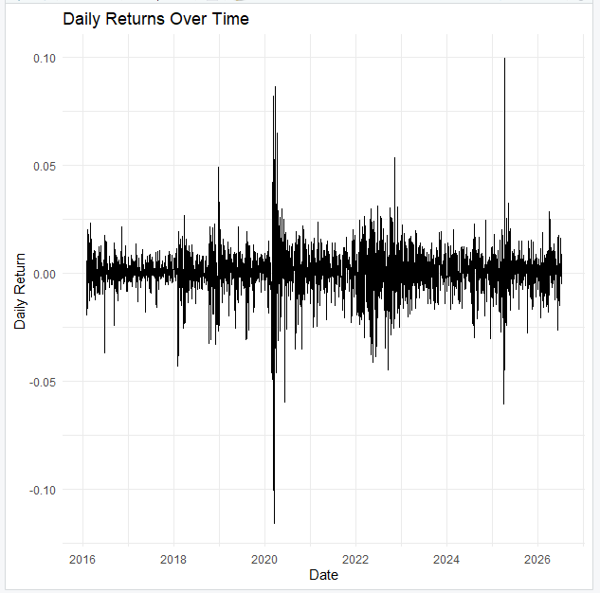

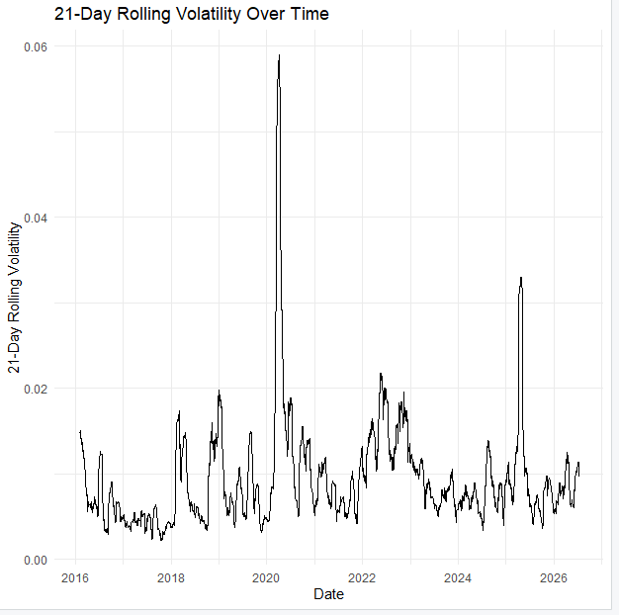

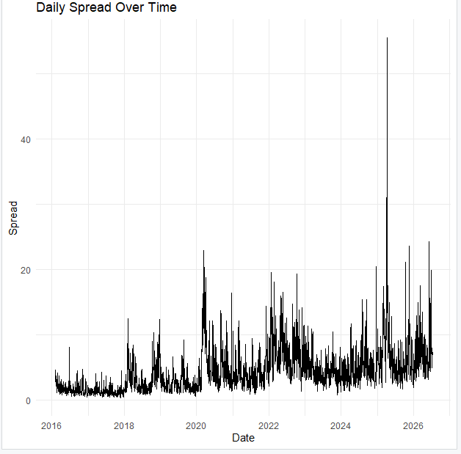
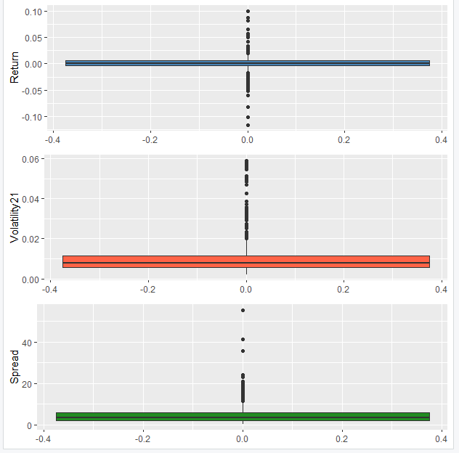

5.2 Interpretation of EDA
Daily Return has a mean of approximately 0.000591, indicating that the average daily logarithmic return in the dataset is slightly positive. Its standard deviation is approximately 0.01122, showing that daily returns vary considerably around the mean.
The Return variable has negative skewness of -0.6039, indicating some asymmetry toward negative returns. Its kurtosis of 18.3243 is substantially high, indicating the presence of relatively extreme observations.
21-Day Rolling Volatility has a mean of approximately 0.00936 and a median of 0.00774. Its positive skewness of 3.7073 indicates a strong right tail, meaning that periods of unusually high volatility occur less frequently than normal-volatility periods.
Daily Spread has a mean of approximately 4.43 and a median of 3.53. Its skewness of 3.1319 indicates a right-skewed distribution. The maximum spread of 55.57 is much higher than the median, indicating the presence of large-spread observations.
Trading Volume has a mean of approximately 80.88 million shares and a median of approximately 72.53 million shares. The positive skewness of 2.6312 indicates that a relatively small number of days have exceptionally high trading volume.
PositiveDay has a mean of 0.5547, which directly represents the proportion of positive trading days in the sample.

6. Correlation Analysis
The correlation matrix for the continuous variables was calculated as follows:
 | Return | Volatility21 | Spread
Return | 1.0000 | 0.0145 | -0.1099
Volatility21 | 0.0145 | 1.0000 | 0.4890
Spread | -0.1099 | 0.4890 | 1.0000

The correlation between Volatility21 and Spread is approximately 0.489, indicating a moderate positive relationship.
The correlation between Return and Volatility21 is approximately 0.0145, indicating very little linear relationship between the two variables in this dataset.
The correlation between Return and Spread is approximately -0.1099, indicating a weak negative linear relationship.

7. Probability Distribution Analysis
The probability distribution analysis was performed separately for discrete and continuous random variables. For discrete variables, empirical PMFs were calculated. For continuous variables, empirical density plots and CDFs were used to describe the distributions.

8. Discrete Random Variable: PositiveDay
PositiveDay is a binary discrete random variable with two possible outcomes. The observed frequencies were:
Outcome | Frequency | Probability
Negative/Non-positive (0) | 1168 | 0.4453
Positive (1) | 1455 | 0.5547
Total | 2623 | 1.0000

The empirical PMF is therefore: P(X = 0) = 0.4453, and P(X = 1) = 0.5547.
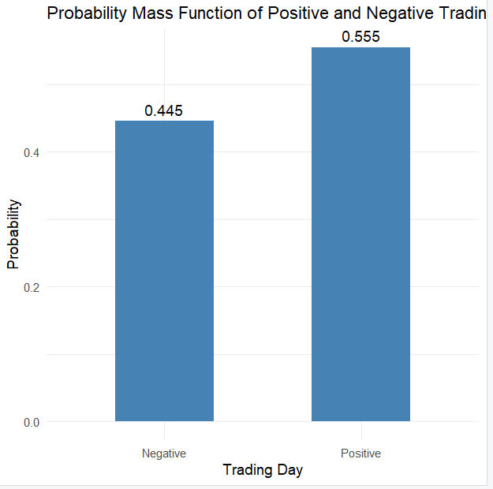

8.1 Bernoulli Distribution
Since PositiveDay has two possible outcomes, it can be represented using a Bernoulli distribution. The estimated Bernoulli parameter is p̂ = 0.5547083. Therefore, P(X = 1) = 0.5547083 and P(X = 0) = 1 − p̂ = 0.4452917.
The empirical and theoretical probabilities are identical because the Bernoulli parameter was estimated directly from the observed proportion of positive days.
Outcome | Empirical Probability | Theoretical Bernoulli Probability
0 | 0.4453 | 0.4453
1 | 0.5547 | 0.5547

9. CDF of PositiveDay
The empirical CDF was calculated using the cumulative sum of the PMF.
Outcome | CDF
Negative (0) | 0.4453
Positive (1) | 1.0000

Therefore, F(0) = 0.4453 and F(1) = 1.
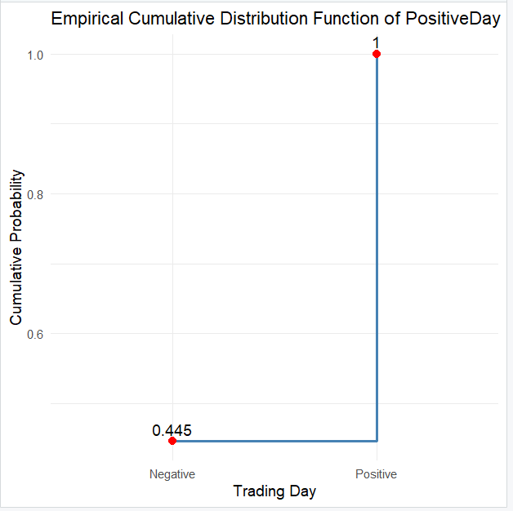
The CDF shows that by the outcome 1, the cumulative probability reaches 1 because all possible outcomes have been included.

10. Discrete Random Variable: Trading Volume
Trading Volume is classified as a discrete random variable because it represents the number of shares traded. There are 2,621 unique trading volume values in the dataset.
The empirical PMF can theoretically be calculated as P(X = x) = (number of observations having volume x) / 2623. However, the large number of unique values makes the empirical PMF extremely sparse. Many individual volume values occur only once, giving a probability of approximately 1/2623 = 0.000381.
For this reason, a PMF bar plot would contain a very large number of bars and would not provide a clear visual representation. Instead, the empirical CDF was used.
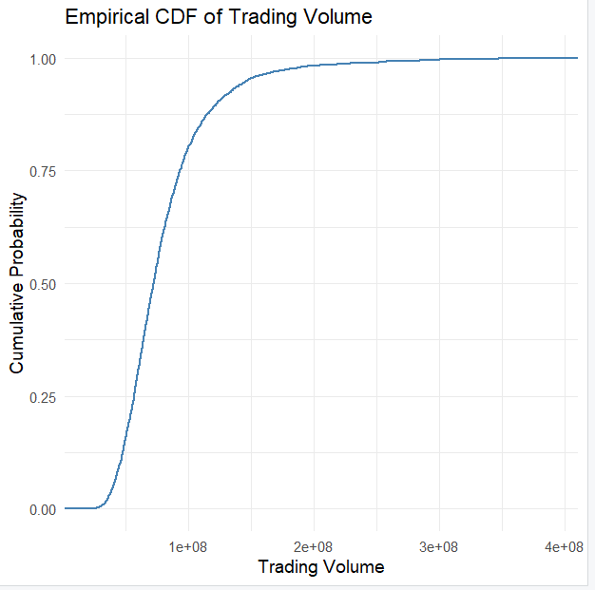
The trading volume ranged from 20,270,000 to 392,220,700 shares. The median volume was approximately 72.53 million shares, while the mean was approximately 80.88 million shares.
The mean being greater than the median is consistent with the positive skewness of 2.6312, indicating the presence of days with unusually high trading volume.

11. Continuous Random Variable: Daily Return
Daily Return is treated as a continuous random variable. The distribution was examined using a histogram scaled to density and a probability density representation.
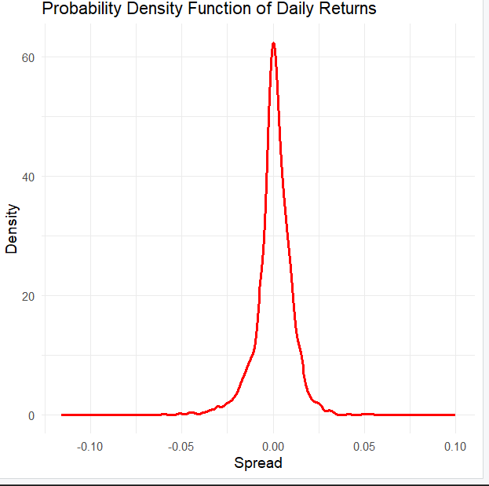

The daily return distribution is centered close to zero, with a mean of 0.000591 and a median of 0.000732. The observed range is -0.115886 ≤ Return ≤ 0.099863.
The negative skewness indicates that the distribution has somewhat greater extension toward negative returns. The high kurtosis indicates that extreme return observations occur more frequently than would be expected under a simple light-tailed distribution.

12. Continuous Random Variable: Daily Spread
Daily Spread is calculated as Spread = High − Low. It is treated as a continuous random variable because the price difference can take decimal values.
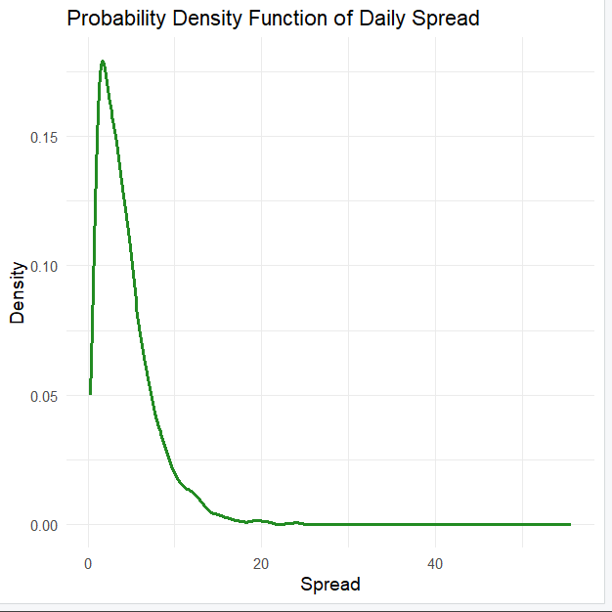
The mean daily spread is approximately 4.43, while the median is 3.53. The distribution has a strong positive skewness of 3.1319. This indicates that most observations are concentrated toward smaller spread values, while a smaller number of observations have substantially larger spreads. The maximum observed spread was 55.57.

13. Continuous Random Variable: 21-Day Rolling Volatility
21-Day Rolling Volatility is calculated using the standard deviation of daily returns over a 21-day rolling window. It is treated as a continuous random variable.
The mean volatility was approximately 0.009359, and the median was 0.007739. The minimum and maximum values were 0.002152 and 0.059005 respectively.
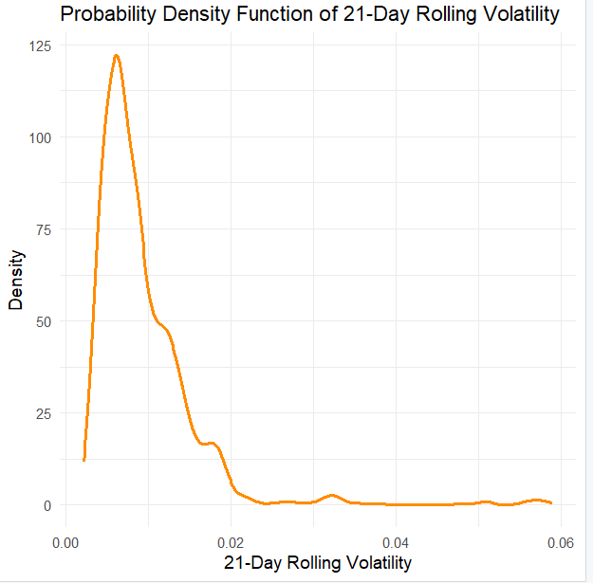
The variable has strong positive skewness of 3.7073, showing that most volatility observations are relatively low while a smaller number of observations correspond to periods of substantially elevated volatility.

14. Empirical CDF Analysis
Empirical CDFs were constructed for the continuous variables. The CDF represents F(x) = P(X ≤ x) and therefore shows the proportion of observations that are less than or equal to a particular value.
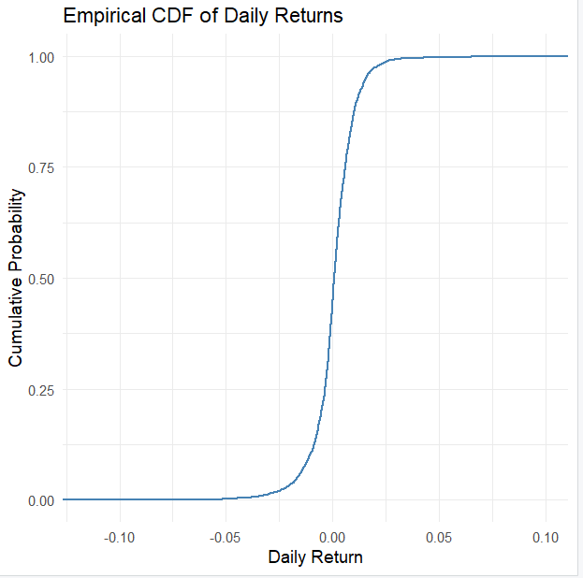
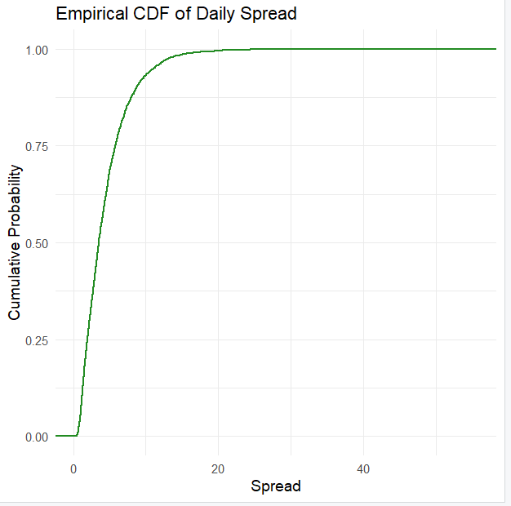
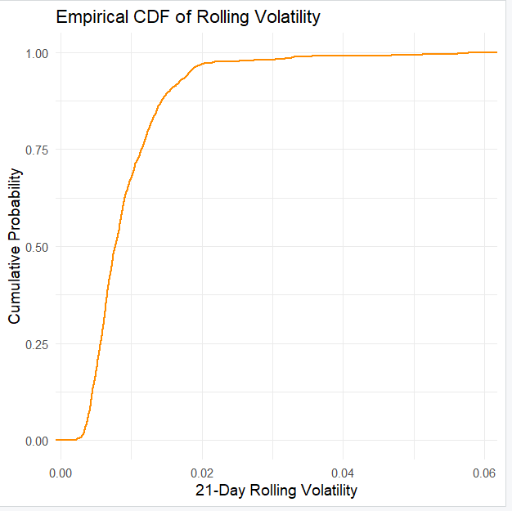
The CDF plots provide a direct way of determining the cumulative proportion of observations below selected values.

15. Additional Analysis: Normal Distribution Fitting
As an additional analysis, a Normal distribution was fitted to the three continuous variables: Daily Return, 21-Day Rolling Volatility, and Daily Spread.
The parameters were estimated using Maximum Likelihood Estimation through the fitdistr() function. The fitted distributions were evaluated using the estimated mean, estimated standard deviation, Log-Likelihood, AIC, and BIC.

15.1 Normal Distribution Fit for Daily Returns
Measure | Value
Mean | 0.0005907
Standard Deviation | 0.0112194
Log-Likelihood | 8055.678
AIC | -16107.36
BIC | -16095.61
Figure 15: Daily Returns with Fitted Normal Distribution
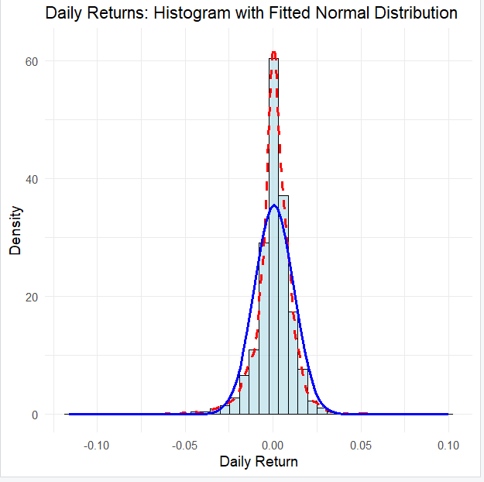
The fitted Normal distribution provides a reference model for the observed return distribution. However, the high kurtosis and negative skewness observed in the EDA indicate that the actual return distribution has characteristics that differ from an ideal symmetric Normal distribution.

Histogram for actual PDF
Red dotted line for Kernel density estimation
Blue line for Normal distribution fit

16. Normal Distribution Fit for 21-Day Rolling Volatility
Measure | Value
Mean | 0.0093594
Standard Deviation | 0.0063383
Log-Likelihood | 9553.513
AIC | -19103.03
BIC | -19091.28

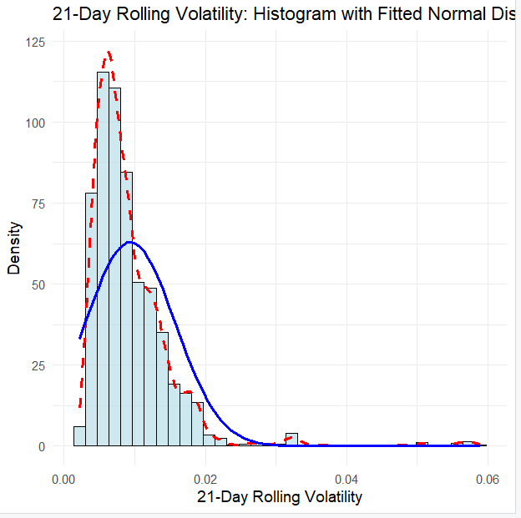
The fitted model provides a theoretical reference for the observed volatility distribution. However, the strong positive skewness of 3.7073 suggests that the actual distribution is substantially asymmetric.
Histogram for actual PDF
Red dotted line for Kernel density estimation
Blue line for Normal distribution fit

17. Normal Distribution Fit for Daily Spread
Measure | Value
Mean | 4.4287
Standard Deviation | 3.5735
Log-Likelihood | -7062.361
AIC | 14128.72
BIC | 14140.47

The Daily Spread distribution has strong positive skewness of 3.1319 and high kurtosis of 27.8864. Therefore, the Normal distribution serves primarily as a fitted reference model rather than a perfect description of the observed data.

Histogram for actual PDF
Red dotted line for Kernel density estimation
Blue line for Normal distribution fit

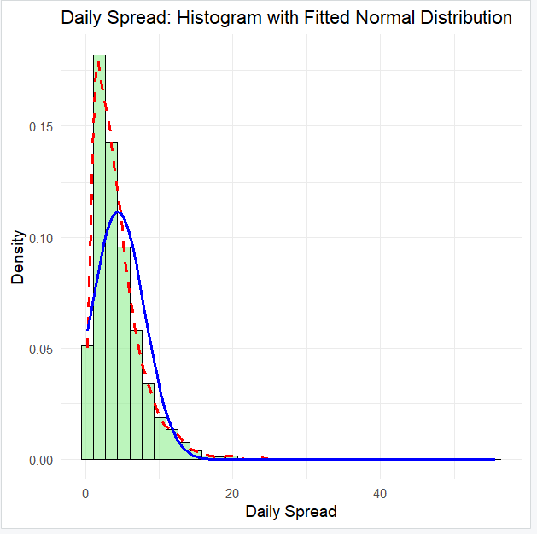
18. Summary of Distribution Analysis
Variable | Type | Distribution Analysis | Main Result
PositiveDay | Discrete | PMF + Bernoulli + CDF | Positive days = 55.47%
Volume | Discrete | PMF + CDF | 2,621 unique values; PMF is highly sparse
Return | Continuous | Density + CDF + Normal fit | Mean close to zero; negative skewness and high kurtosis
Spread | Continuous | Density + CDF + Normal fit | Strong right skew and high kurtosis
Volatility21 | Continuous | Density + CDF + Normal fit | Strong right skew; higher volatility periods occur less frequently

19. Key Findings

Finding 1: Positive trading days were more frequent
Out of 2,623 observations, 1,455 were positive trading days, corresponding to a probability of approximately P(PositiveDay = 1) = 0.5547. Thus, approximately 55.47% of the observed trading days had positive returns, while approximately 44.53% were negative or non-positive.

Finding 2: Daily returns are centered close to zero but contain extreme observations
The mean daily return was only 0.000591, indicating that the average daily return was close to zero. However, the kurtosis of 18.3243 indicates substantial tail behavior, with some observations far from the center of the distribution.

Finding 3: Volatility is strongly right-skewed
The 21-day rolling volatility has skewness of 3.7073. Its mean of 0.00936 is higher than its median of 0.00774, which is consistent with a right-skewed distribution. This indicates that periods of unusually high volatility occur occasionally and produce a long right tail.

Finding 4: Trading volume is highly right-skewed
Trading volume has a mean of approximately 80.88 million and a median of approximately 72.53 million shares. Its skewness of 2.6312 indicates that unusually high-volume trading days increase the mean.

Finding 5: Spread and volatility have a moderate positive relationship
The correlation between Daily Spread and 21-Day Rolling Volatility is approximately r = 0.489. This represents a moderate positive linear relationship, suggesting that larger daily trading ranges tend to be associated with periods of higher volatility.

Finding 6: Volume has a sparse empirical PMF
Although Volume is discrete, it has 2,621 unique values among 2,623 observations. As a result, most individual volume values occur only once and have a very small empirical probability. Consequently, the empirical CDF provides a more useful visual summary than a PMF bar chart.

20. Overall Statistical Workflow
The complete analysis can be summarized as follows:
- 1. Data Collection — SPY historical data was obtained from Yahoo Finance.
- 2. Data Preparation — Daily returns, spread, positive-day indicator, and 21-day volatility were calculated.
- 3. Data Cleaning — Missing observations were removed.
- 4. Variable Selection — Five variables were selected for probability analysis.
- 5. Classification — Variables were classified as discrete or continuous.
- 6. Exploratory Data Analysis — Mean, median, SD, variance, minimum, maximum, skewness, and kurtosis were calculated.
- 7. Visualization — Histograms, density plots, boxplots, and CDF plots were generated.
- 8. Discrete Distribution Analysis — PMF and CDF were calculated for PositiveDay and Volume.
- 9. Continuous Distribution Analysis — Density functions and empirical CDFs were examined for Return, Spread, and Volatility21.
- 10. Distribution Fitting — Normal distributions were fitted using Maximum Likelihood Estimation.
- 11. Model Evaluation — Log-Likelihood, AIC, and BIC were calculated.
- 12. Interpretation — The distributions were interpreted using their probability values, shape, skewness, kurtosis, and relationships between variables.

21. Conclusion
This study demonstrated the application of probability distribution concepts to real-world financial data. Five variables from SPY market data were classified into discrete and continuous random variables and analyzed using appropriate statistical techniques.
PositiveDay provided a clear example of a discrete Bernoulli random variable, with a probability of approximately 0.5547 for a positive trading day. Trading Volume was also classified as discrete, although its large number of unique values resulted in a sparse empirical PMF.
Daily Return, Daily Spread, and 21-Day Rolling Volatility were analyzed as continuous random variables using density functions and empirical CDFs. The analysis showed that these variables exhibit varying degrees of skewness and substantial kurtosis.
The additional Normal distribution fitting provided theoretical reference models for the continuous variables. Comparison with the EDA statistics showed that the observed data, particularly volatility and spread, exhibit considerable asymmetry and tail behavior.
Overall, the analysis demonstrates how real-world financial data can be used to distinguish between discrete and continuous random variables, construct empirical probability distributions, examine cumulative probabilities, and interpret the statistical characteristics of observed data.

22. References
- Yahoo Finance – Historical SPY market data.
- R Statistical Computing Environment.
- R packages used in the analysis: quantmod, tidyverse, PerformanceAnalytics, TTR, lubridate, MASS, moments, and ggplot2.

23. Appendix: R Programming Workflow
The analysis was implemented in R. The major packages used were:
- quantmod – obtaining financial market data.
- tidyverse – data manipulation and analysis.
- ggplot2 – statistical visualization.
- PerformanceAnalytics – financial data analysis.
- TTR – technical analysis calculations.
- lubridate – date handling.
- MASS – Normal distribution fitting using maximum likelihood.
- moments – skewness and kurtosis calculations.
The complete R scripts used for data collection, EDA, PMF, PDF, CDF, and Normal distribution fitting can be included in the appendix.

